**Summary of Chapter 11**

* **Organisational Culture**
  + A system of shared meanings and common beliefs held by organisational members that determines, in a large degree, how they act towards each other.

**Looks at the following areas**

* + - Values
      * The regard that something is held to deserve; the importance, worth, or usefulness of something.
    - Symbols
      * A shape or sign used to represent something such as an organization
    - Rituals
      * A series of actions or type of behavior regularly and invariably followed by someone.
    - Myths
      * A traditional story, especially one concerning the early history of a people.
    - Practices
      * The actual application or use of an idea, belief, or method, as opposed to theories relating to it.

**Implications of organizational culture**

* + - Culture is a perception.
      * The way in which something is regarded, understood, or interpreted.
    - Culture is shared.
      * Possessed in common with another or others.
    - Culture is descriptive.
      * Serving or seeking to describe.

**Seven Dimensions of Organisational Culture**

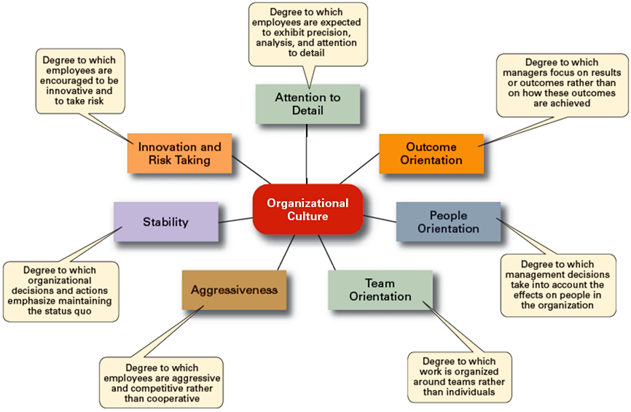

1. **Attention to Details**
   * + Is the ability to achieve thoroughness and accuracy when accomplishing a task.
2. **Outcome Orientation**
   * + The degree to which managers focus on results or outcomes rather than on techniques and processes used to achieve these outcomes.
3. **People Orientation** 
   * + Is generally used to convey something vaguely like a company where everyone is friends. They all get along, are pleasant and happy and smile at each other when they pass in the halls. It's fun to work there, everyone likes their job, and each employee is treated well and fairly.
4. **Team Orientation**
   * + The degree to which the organizational members stress collaboration and cooperation in. performing business activities and in making business decisions
5. **Aggressiveness**
   * + Determination and forcefulness.
6. **Stability** 
   * + Stability is the state of being resistant to change and not prone to wild fluctuations in emotion.
7. **Innovation and Risk Taking**
   * + Managers who are open to new ideas and are willing to **take risks** to make things better gain the respect of their team members, are more quickly promoted, and develop a reputation as “go to” people for the development of new ideas.

* **Strong Cultures**
  + Are cultures in which key values are deeply held and widely held.
  + Have a strong influence on organisational members.
* **Factors Influencing the Strength of Culture**
  + Size of the organisation
  + Age of the organisation
  + Rate of employee turnover
  + Strength of the original culture
  + Clarity of cultural values and beliefs
* **Benefits of a Strong Culture**
  + Creates a stronger employee commitment to the organisation.
  + Aids in the recruitment and socialisation of new employees.
  + Fosters higher organisational performance by instilling and   
    promoting employee initiative.

**Difference between Strong and Weak Cultures**

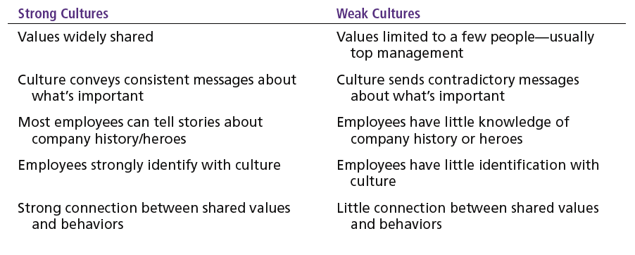

**How Employees Learn Culture**

* **Stories**
  + Narratives of significant events or actions of people that convey the spirit of the organisation
* **Rituals**
  + Repetitive sequences of activities that express and reinforce the values of the organisation
* **Material Symbols**
  + Physical assets distinguishing the organisation
* **Language**
  + Acronyms and jargon of terms, phrases, and word meanings specific to an organisation